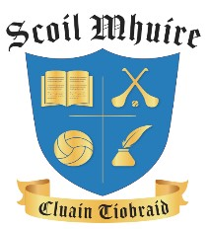
_____________________________________________________________________________________
Revised Parental Complaints Procedure
Scoil Mhuire, Clontibret
______________________________________________________________________________ Purpose / Objective:
The parental complaints procedure was revised and agreed by the Irish National Teachers’ Organisation and the management bodies of primary schools, the Catholic Primary Schools Management Association, the Church of Ireland, An Foras Pátrúnachta, the Muslim Primary Education Board, Educate Together and the National Association of Boards of Management in Special Education in 2023.
It is designed to provide an open and clearly defined process to facilitate parents/ legal guardians in raising concerns about their own child/children in an agreed, fair and transparent manner.
It is recognised that the parents/ legal guardians are the primary educators in a child’s life and as such from time to time concerns may arise which they may need to engage with the school. It is expected that engagement will be timely, courteous and resolution focussed to ensure that the important relationship between the parent and school can be preserved and respected. It is expected that all parties concerned will engage proactively.
Ratification & Communication

This Revised Parental Complaints Procedure was ratified and adopted by the Board of Management at a meeting on the 25th January 2024.
A copy of the Revised Parental Complaints Procedure will be given to all teachers, it will be emailed to the parents/ guardians and will be available to the school community on the school website, www.scoilmhuireclontibret.ie.
Signed on behalf of the Board of Management:

Chairperson: Matthew McKenna Date: 25th January 2024
Principal: Elizabeth Moorehead Date: 25th January 2024
1
Revised Parental Complaints Procedure Scoil Mhuire, Clontibret, Roll No. 18539A

